POLICIES & PROCEDURES
Created by: Edward Dana

Employees MUST Log-in Super Stop Online Training Portal at

www.SuperStop.us

At least once a month

Amended reflecting NOT offering
Money Transfer services
Date: August 1st. 2011
Last Amended Date: July 1st. 2011

INTERNAL CONTROL GUIDE
CASH COLLECTIONS
INTRODUCTION

Cash is the most liquid of assets and is susceptible to loss if not properly controlled.
Therefore, it is extremely important all departments handling cash implement and adhere to strong internal controls. For the purposes of this guide, “cash” includes coins, Currency, checks, money orders, internal charges and credit card transactions.
This Internal Control Guide provides guidance to Super Stop employees with regard to safeguarding cash. Please use this guide to develop cash handling procedures in our business.
Super Stop Employees MUST work on registers using their designated Log-in Credentials ONLY

OVERVIEW OF CASH HANDLING

The Compliance Officer or any of his administrative appointees is responsible for monitoring, processing and recording the collection of funds that come into Super Stop Market

Collections of funds at Super Stop Market are monitored, processed, and manager should distribute and deposit funds to the bank, as appropriate, in the course of normal operations. All employees collecting cash should ensure proper controls are in place to safeguard collections until final bank deposit.
All clerks collecting funds may be subject to periodic, unannounced audits and check-ups by the officers, mangers or administrators.
In addition to collections, cash may be present in store for use as a change fund, check cashing funds or petty cash fund. A change fund earmarks an amount of cash to provide change for customers who make purchases from the store. A petty cash fund earmarks an amount of cash to be used by the store clerk to handle small, miscellaneous emergency purchases. In some cases the petty cash purchases would be paid by the clerk using his register cash sales if petty cash was not available. Clerk MUST record all pay outs on his final closing.

SEPARATION OF CASH HANDLING DUTIES

Cash handling duties can be divided into three stages: receiving, depositing, and reconciling. Ideally, all three stages might be performed by different individuals.
RECOMMENDED CONTROLS – RECEIVING CASH

In case of Receiving Checks and Money Orders
- All checks and money orders should be made payable to “Super Stop Market.”
- All checks should be restrictively endorsed at the time of receipt with “For Deposit Only,” along with the store name “Super Stop Market.”
- Payroll checks are cashed according to our check cashing system in place and clerk will be subject to pay for returned checks clerk cashed without following our check cashing system procedures.
- Prove of identity is required when processing a credit card transaction.
- Cash drawers, complete with a change fund, will always be fully prepared and secured.
- Change funds are not to be used by any employee for personal purposes.
- If a Super Stop employee is confronted with an armed assailant, or someone who proclaims to be armed, they will not resist and hand over all monies.
- It is critical to make cash drops into the safe when cash exceed more than $300.00 in one register.
- The numeric amount of the check must agree with the written amount.
- Checks must have the current date (no postdated checks).
- Change should never be given for a check over the amount due.
- If possible, each cashier should start his/her shift with new beginning cash balance and his/her own cash drawer. If a register must be shared, it must have sufficient controls to allow collections to be attributed to individual cashiers (e.g., separate user IDs and passwords to access the register).
- Cash register entries should be made at the time of the transaction, and the payer should be given a cash register receipt.
- Each cashier should balance his/her register activity at the end of the business shift.
- Store manager or a designated individual must verify that the cash received matches the cash register’s report of business by cashier.
- All voids and refunds should be reviewed and approved by management and should be documented Safeguarding Handling and Storage of Cash
- All sales MUST be processed through the store registers.
- The customer should be given a copy of the receipt at the time of purchase if requested.
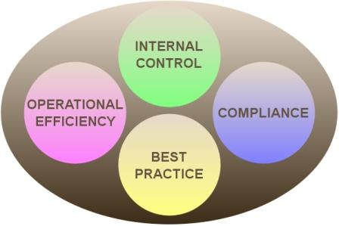
- You should never leave sales cash in an open unsecure area to customers all sales should be held in a secure manner until deposited. This may be accomplished by such means as a fireproof safe, a desk drawer, or other locked device.
- Access to secure locations via keys or combinations should be limited to authorize individuals only.
- Sales should be handled by employees as fast and as safe as possible.
- If cash is transferred to another clerk or employee, accountability procedures should be followed.

RECOMMENDED CONTROLS – DEPOSITING CASH

- All sales should finally be deposited with bank
- All deposits remitted to bank must be accompanied by a completed register closing Report/Receipts Voucher (sales Report). The sales Report must identify the source of the funds.
- All supporting documentation, including daily cashier reports, a daily summation of receipts, and bank deposit slips should be included in the final report.
- Persons collecting and recording funds should not prepare deposits.
- Deposits must be made in a timely manner, with as little cash as possible being kept in store and manager should make daily deposits.
- When cash is deposited or when large sums of cash are on hand, departments are encouraged to ask for a police escort.

RECOMMENDED CONTROLS – RECONCILING CASH-RELATED ACTIVITY

- Reconciliations should be completed by the manager or a designated personnel the compliance officer should review the reconciliation process.
- Daily reconciliations should be performed by a specified individual, comparing the following:
- the cash receipt records (e.g., cash register balancing records, receipts, and cash drops) the completed sales Report
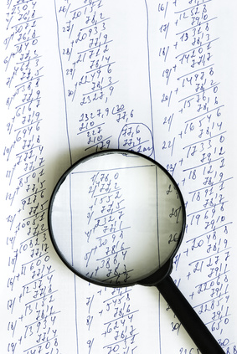
- Monthly Western Union money transfer review should be performed by the compliance officer to look for suspicious activities by looking over all senders for the month.
- All differences should be documented and resolved promptly.

CASH HANDELING

RESOURCES

If you have questions regarding cash handling procedures, you may ask:
- Edward Dana (502) 387-6133
- Ali Dana (502) 718-9023
- Sahar Dana (502) 387-6133
- Rana Dana (502) 944-6297

Cash Deposits and Reconciliation

PURPOSE In order to maintain adequate internal controls, cash deposits and reconciliation submissions must be made on a daily basis if possible. The cash deposit must be placed in a blue bag and taken to the bank daily on working business days.

RESPONSIBILITY:

Store Manager Edward Dana or Ali Dana

ACTION

- Prepares daily cash deposit to include cash and checks. Prepares Super Stop deposit slip.
- The reconciler places the patient receipt copies, credit card receipts and batch settlement, and reconciliation form into file.
- The reconciler takes the deposit to the bank or places the deposit bag in a secured area until its taken to the bank.

All cash transactions must be recorded, documented and filed

Super Stop must renew its Money Services Business license every 2 years.

Cash Drawer Procedures
Purpose | The Cash Drawer is defined as the working cash used in each cash drawer.  - Petty Cash cannot be kept in the Cash Drawer.  - Customer service requests for parking and telephone change and petty cash needs are acceptable uses of the Cash Drawer.
Policy | RESPONSIBILITY  Store Manager  ACTION  - Each drawer should be setup with an initial $128.00. The break down should follow a pattern similar to the one given below. This is only a guideline and, as drawers run low of a certain denomination, that denomination will need to be replenished.  Pennies (two rolls) $1.00  Nickels (one roll) $2.00  Dimes (one roll) $5.00  Quarters (one roll) $10.00  Ones $30.00  Fives $30.00  Tens $50.00  - As cash is given out for change and taken in for payment, the composition of the drawer will change. Observe which denomination has the most activity and order more of that denomination than other currency and coin that is not given out as much. An example is that quarters are used more frequently than one dollar bills. Dollar bills should be taken in exchange for quarters in this example, so less one dollar bills are needed and more quarters would be kept on hand.  - As additional change is needed to replenish the change fund the manager will take it out of our company bank account  - For internal control purposes it is recommended that a drawer be provided to each employee handling cash.  RESPONSIBILITY  Manager  - Unannounced periodic cash counts of the cash drawers will take place on an ongoing basis.  RESPONSIBILITY  Cashier  - Change may be given to customers for non-payment type exchanges; this might include change for parking and telephone use. When change is provided to the customers, the cashier should ensure that equal amounts are exchanged.

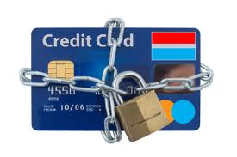
Processing Credit Card Payments

PURPOSE Store Clerk is responsible to accommodate credit card transactions.
RESPONSIBILTITY
Clerk
ACTION
  - Receive request to make payment by credit card.
  - Swipe credit card (VISA, MasterCard, Discover, or American Express) through credit card terminal (OMNI Machine or on-line process).
  - Enter amount of payment on credit card terminal and press enter.
  - Credit card terminal prints authorization number on sales draft.
  - Ask cardholder to sign sales draft.
  - If the credit card transaction cannot be completed due to an error message on the credit card terminal (such as an over limit, fraudulent card, or any other reason) return the card to the customer and ask for another form of payment.

Proper handling of credit card information for Compliance
Responsibility
Anyone Accepting Credit Card Payment
Due to increased global threat of identity theft and compliance requirements from our financial institutions and merchant service providers, increased diligence is required for all service sites processing credit card payments or refunds. The following applies to sensitive credit card information:
- The cardholder and account information (name, address, full account number, and expiration date or 3-digit security code on the back of the card) must not be retained once the card processing is complete.
- Examples of improper retention include, maintaining electronic spreadsheets or databases with such information listed, keeping hard-copy file folders with this data in a written format, or maintaining such information in e-mails.
- If such information is presented to you (i.e. a third party written authorization or is written down as a reference to complete the transaction), it must be promptly and safely destroyed using a shredder in manager office.
- Treasury and CFS may, as part of ongoing compliance requirements, conduct random service site procedure evaluations. Site managers may also periodically be requested to complete a compliance questionnaire for internal control purposes.

Voiding Credit Card Transactions

PURPOSE Follow this procedure to cancel a credit card transaction if an error is made in the amount of the transaction, and the credit card machine has not been batch settled.
RESPONSIBILTITY
Clerk

ACTION
- Press void on the credit card terminal
- To void a transaction by the ticket number, press 1 and then press enter/yes.
- Enter the ticket number of transaction and press enter/yes.
- If the ticket number and amount of transaction is correct, press enter/yes.
  - A voided receipt will print. Circle the word “VOID” and keep with credit card transactions until settlement procedure is performed.
  - If ticket number and/or amount of a transaction are incorrect, press clear/no and start again.

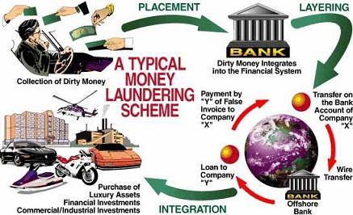

Check Cashing Policies & Procedures

Stop Check Fraud

Non-Sufficient Funds Policy and Procedure
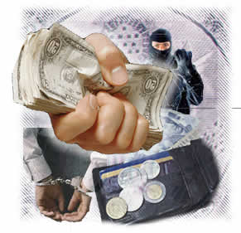
PURPOSE This procedure outlines the steps taken when cashed checks are returned by the bank for NON-sufficient funds/stop payment/account closed (NSF). Returned checks require a sequence of actions.
RESPONSIBILITY
Follow Store Procedures
Staff

ACTION
- Receive returned check then print a transaction report from the check cashing computer.
- Review the endorsement stamp and receipt number on the back of the check. Identify which clerk cashed the check.
- Cashier or manager should call customer and investigate why check was returned.
- Call company, organization or government department that issued the check and investigate why check was returned.
- Always talk to customer about their legal obligation and the consequences they face if they don’t co-operate and help us in getting our money back.
Super Stop provides check-cashing service to customers that have a valid Kentucky driver license or a valid Kentucky identification card.

Daily Check Cashing Limits

The check cashing limit is a minimum of $5 up to a maximum of $1000.00
Checks over $1000 will require a manager presence and approval to cash.
Suspension of Check Cashing Privilege
Super Stop Market reserves the right to suspend or terminate a customer check cashing privileges for returned checks or other financial reasons. If the returned checks are the result of a bank or a company error and were reimbursed, the privilege will be reinstated.

Collection of Returned Checks
A $35 fee will be charged for each returned check. The customer will be notified by phone and required to respond within three (3) business days. Failure to respond to this notice will result in a legal action.
Follow the collection of a returned check procedure.
.
SUPER STOP IS A REGISTERED MONEY SERVICE BUSINESS

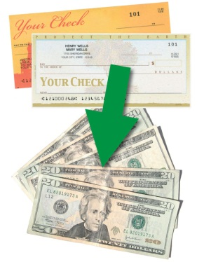
Allowable Check Cashing
- Payroll checks.
- Government checks.
- Insurance checks.
- Money Orders
- Income tax refund checks

Fees for Check Cashing
Super Stop fee will be based on the following schedule:

Check amount | Fee
$100.00 | 2%
$100 $200 | 2%
$200 $300 | 2%
$300 + | 2.5%
Periodic Sales discounts | We cash checks for change

Limitation and Requirements For Check Cashing

Customers: a valid official picture ID (i.e. valid Driver's License, Government issued picture ID.

All Others: Valid green Card alien resident card or passport.

Information required every time we cash a check
- Signature endorsement on back of check
- Current address and telephone number and if it doesn’t match the customer information in our database please correct it

Third-Party Checks
A third-party check is a check that is written to one person, and then signed over to another person.
SUPER STOP DOES NOT ACCEPT THIRD-PARTY CHECKS
Handwritten Checks
Do not accept checks that are not typed or computer generated. Handwritten checks could be stolen with a forged signature.
Check Number Limit
The number of checks each customer can cash per month is 4 checks.
Check Cashing System
Super Stop check cashing system is innovation database software to help and speed the check cashing process. It is very important that all customer information in our database is correct and updated every time the customer return to our store.
Fingerprint
Super Stop requires the customer to include a finger or thumb print in our database along with the ID and signature endorsement. If the check clears, there is no issue. However, if the check is returned for insufficient funds or as a stolen or forged check, the fingerprint can be cross-checked for criminal activity. You can include this as a check cashing procedure.
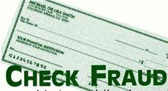
Taking a picture of the Customer
Super Stop requires taking a current picture to our check cashing returned customers.
Check Fraud Scenarios
When a check is returned and we failed to communicate or get reimbursed for our loss by the customer or the check issuer the store manager or clerk should proceed with the following:
- Store manager or clerk must call Louisville Check Fraud unit at: (502) XXX-XXXX
- Prepare 2 complete check transaction report from our check cashing system including all customer and check information. A copy goes to the Fraud unit and the second for our internal filling.
Check Drops and deposits
When a check is cashed it will have to be dropped into our safe immediately as soon as possible and after cash reconciliation all checks MUST be deposited in the bank account to get credited as fast as possible.
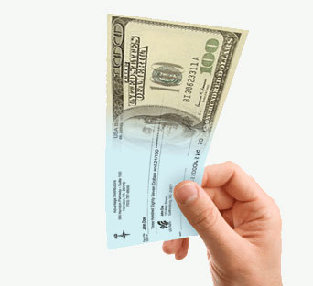
CTR Preparations
When to file a CTR:
- If a customer bring a check that is more than $10,000 or more.
- If a customer bring 2 checks totaling $10,000 or more.
Cashing Money Orders
When to cash a money order:
- Money order MUST be blank and not filled out
- Money order MUST have the stub that is attached to it.
- Customer must have valid identification.
- Money orders are not processed into our check cashing system because they are not payroll checks.
Employee Responsibility for returned checks
When a check is returned for any reason due to clerk error Super Stop reserve the right to charge clerk for the full amount of the check including any charges that might occur by our financial institution
RECORD DISPOSAL REQUIREMENTS UNDER THE BUSINESS ADMINISTRATION ACT

All Employees must understand the proper disposal of Super Stop records that contain the following:
- Sensitive information about a customer’s medical condition
- Certain financial data relating to a customer’s account or transaction with Super Stop
- Data provided by a customer to Super Stop upon any financial transaction.
- Data about a customer’s federal, state, or local tax return.

Once such records are no longer needed, Super Stop must do one of the following before discarding them:
- Shred the record
- Erase the personal information contained in the record
- Modify the record so that the personal information is unreadable
- Take actions that will ensure that no unauthorized person will have access to the personal information contained in the records.

Improper disposal of records containing personal information may result in loosing you job and serious legal actions.
Check Cashing Responsibilities
DO NOT Cash Checks more than $500 without manager APPROVAL
- Report fraudulent or forged checks.
- Super Stop will maintain digital logs of checks cashed.
- Maintain a daily reconcilement of cash.
- Provide all customers with a receipt.
- Post fees charged for cashing checks.
- Post the license in plain view.

EBT Food Stamp SNAP requirement for business accepting EBT cards program.

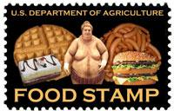
What foods can customers buy with SNAP food stamps?
- Customers can use SNAP food stamps to buy any food item except food that is hot when sold, or food that is sold to be eaten in the store like restaurant food. Eligible food items include:
  - any food products or ingredients used to prepare meals at home
  - cold prepared sandwiches, salads, and other deli items
  - ethnic and health foods
  - snack foods, candy, soda, and ice
- Customers can use SNAP food stamps to buy seeds or plants that they will grow to produce food for their household.
- Customers cannot use SNAP food stamps to buy non-food items like alcoholic beverages, cigarettes, vitamins or medicines, pet foods, soap, cosmetics, laundry products, paper goods, or other household products.
Access Services Training Portal on our Website Periodically

What rules do I have to follow?
Super Stop management will explain the rules employees must follow for the SNAP Food Stamp Program. They will also explain the penalties for not following the rules. Some of the most important rules are:
- You can only accept SNAP food stamps for eligible food items.
- You cannot charge sales tax on any items bought with SNAP food stamps.
- You cannot accept SNAP food stamps as payment on credit accounts. Your food stamp customers must pay for their purchases at the time of sale. You cannot give them credit and let them pay you back with SNAP food stamps at a later date.
- You cannot give cash in exchange for SNAP food stamps.
- You cannot give cash change for SNAP purchases. The amount charged to the customer's EBT account must be the exact amount of the food purchase.
- You cannot give cash refunds for food bought with SNAP food stamps. Refunds must go to the customer's EBT account.
- You cannot process a SNAP purchase unless the customer has the EBT card and PIN.
- You must treat SNAP food stamp customers and other customers the same. For example, you cannot have a special line for SNAP food stamp customers, or charge them higher prices, or require a minimum purchase.
You must follow all of the SNAP Food Stamp Program rules and regulations. If you do not follow the rules, you can lose your job. You may also be subject to a legal action.
Money Orders | Money Order Record – Consumer Identification and Recordkeeping Requirements for Money Orders
Purpose: | To establish policies and procedures for the consistent review, verification, and recording of consumer identification and transaction information for money order purchases of $3,000 or more (inclusive of fees) by or on behalf of a single consumer in any one day.
Procedures:  4. Employees must look at and handle the consumer’s ID to verify the consumer’s identity and the ID’s authenticity. If an ID is not provided, does not match the consumer, or appears to be fake the employee must refuse the transaction.  5. Employees must obtain and record the following information on the Money Order Record:  • Purchase Date  • Total number of Money Orders sold | Consumer Identification Requirements for Money Orders --$3,000 or more  1. For all Money Order purchases of $3,000 or more (inclusive of fees), whether purchased singly or in the aggregate, by or on behalf of a consumer in any one day, employees must obtain and record the following consumer and transaction information.  2. Employees are required to review an acceptable form of consumer identification and ensure that the identification:  • Is currently valid (i.e., has not expired)  • Is government issued  • Contains a photograph of the consumer  • Contains the consumer’s name  • Contains the consumer’s address (preferred)  3. Employees must determine that the form of identification is acceptable by Super Stop policy. Examples of acceptable forms of identification include the following:  • Driver’s License  • Passport  • US Permanent Resident Card (green card)  • Military I.D. Card  • Mexican Consulate Issued Matricula Card

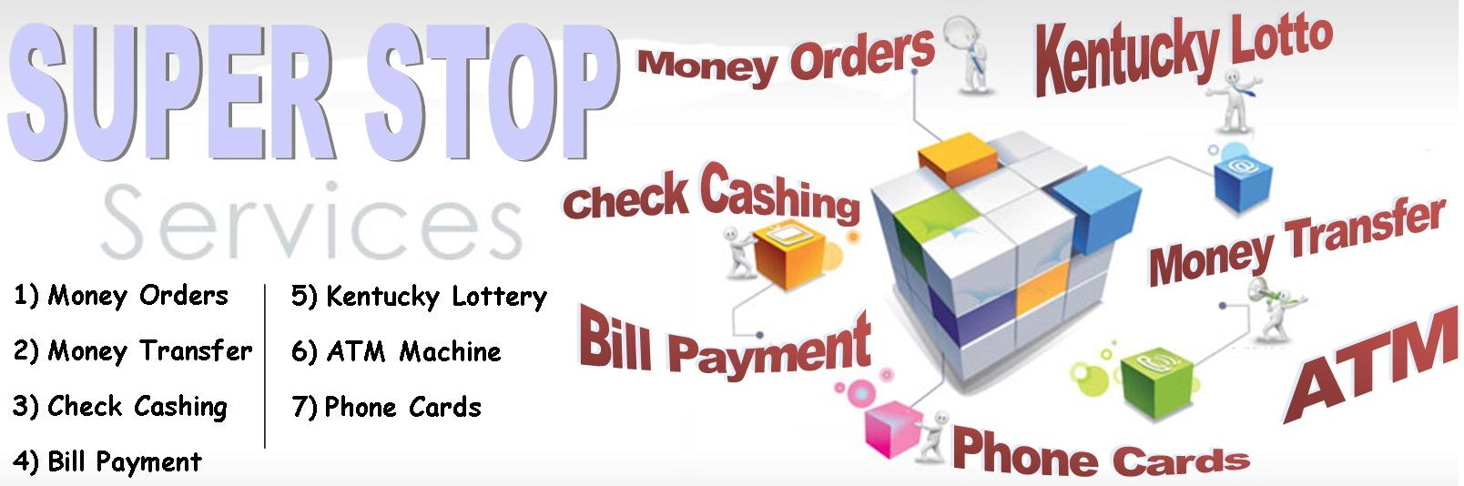

- Money Orders Global Express
- Bill Payment Global Express
- Kentucky Lottery Kentucky Lottery
- ATM Machine CPR Financial
- Phone Cards Different Distributors
- Check Cashing

